Hemel Hempstead District Squirrels, Beavers and Cubs
District Christmas Pantomime Outing
Dear Leaders, 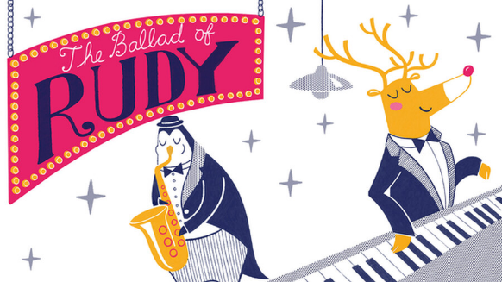
Please find attached a letter for Squirrels, Beavers and Cubs about our Christmas Pantomime Outing.
We have booked two performances of the Ballad of Rudy at the Old Town Hall:
Sunday 17th December 2.00pm – 2.45pm
Sunday 17th December 5.30pm- 6.15pm
We have 92 child seats and 18 leader seats for each performance, therefore the ratios will be 1 adult to every 6 young people and tickets are only bookable as 6 young people and an adult. If you have an odd number of young people let me know and I will match you with another group in the District to book on together. This was the simplest way we could find of keeping the ratios correct.
The cost of the tickets for children is £10. Leaders are free. The deadline to book tickets is Friday 27th October.
We hope your Drey, Colony, Pack will want to come along. Tickets are offered on a first-come first-served basis.
Please choose the performance you would like your Drey, Colony, Pack to come along to and edit the attached letter as shown.
Tickets may be booked via the District Website
2:30pm performance - https://www.hemel-scouts.co.uk/upcoming-events/panto-2023-early/
5:00pm performance - https://www.hemel-scouts.co.uk/upcoming-events/christmas-panto-late/
Any questions, please email, text, message me on 07702 183157.
Richard Haynes

