Hemel Hempstead District Squirrels, Beavers and Cubs
District Christmas Pantomime Outing
Dear Squirrels, Beavers and Cubs, 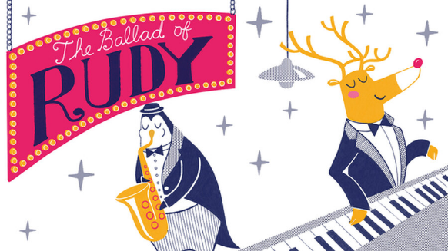
Join us for a festive treat this Christmas.
We are going to see The Ballad of Rudy, a musical pantomime, at the Old Town Hall in Hemel Hempstead on:
Sunday 17th December 2.00pm (delete as appropriate)
Sunday 17th December 5.30pm (delete as appropriate)
Arrive at the Old Town Hall in uniform by 1.45/5.15pm (delete as appropriate)
You will be met by our leaders and seated with your friends
You can bring a small packet of sweets if you want to.
The performance lasts 45 minutes and you can be collected at 2.45/6.15pm (delete as appropriate)
The cost of a ticket is £10
Tickets are sold on a first come first served basis
To book a place for your child please….(enter your Group’s booking/payment details here)
If you have any questions please contact.. (enter your contact details here)

