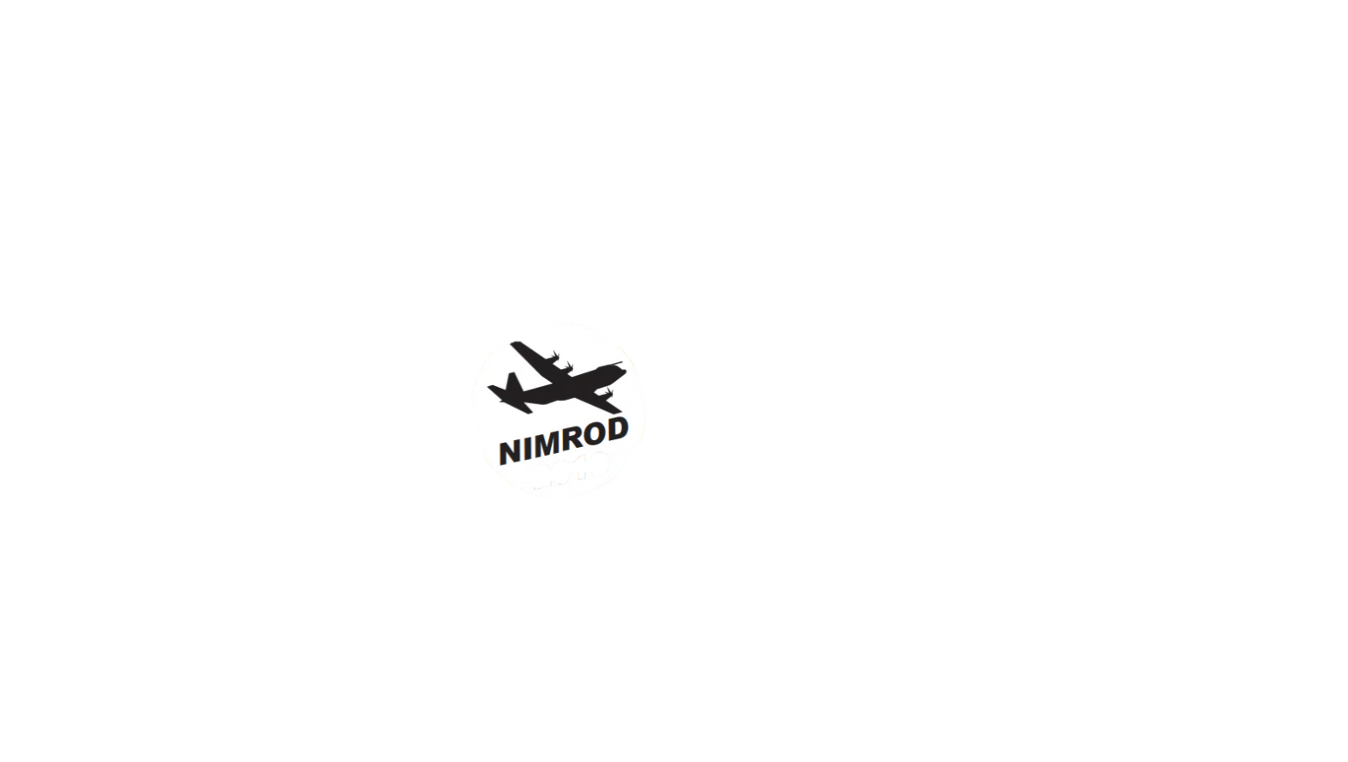**NIMROD 2024**

**COMPETITION INFORMATION**

Dear Scout

You are invited to take part in **Nimrod 2024**. There are two competitions running at the same time, Nimrod itself and also the Dave Barnes training competition for less experienced and younger Scouts. The event will be held from 3.00pm on Saturday 29th June to 10.30am on Sunday 30th June 2024 based at Phasels Wood and we look forward to receiving your entry!

**Competition Summary**

Nimrod is a night hike competition with several team challenge bases to visit and clipper points to find. Map co-ordinates will be given at the start of the competition so you can plan your route.

The competition (and scoring!) begins as soon your team arrives at signing-in area on Saturday afternoon and ends when breakfast and tents are packed away on Sunday morning. Teams should arrive together and in full smart uniform and will get an information pack to read at the start.

**Competitive Teams**

Competitive teams should consist of 4-6 invested Scouts. Each team will have an adult hiking with you but they will not be allowed onto the competition camping area at all and will not help you with tents, route plotting or cooking. Leaders walking with competing teams will not help you navigate unless safety is a problem.

**Training Teams**

There is a separate training competition for teams of 4-6 Scouts (with a maximum of 2 Cubs on a linking activity). The aim of this competition is to enable less experienced and younger Scouts to participate in the competition for the first time with the support of a leader. You will have a leader supporting you at all times throughout the competition and they will hike with you.

**Scoring**

You will be scored throughout the competition in the categories below and any Leader or Explorer helping to run Nimrod could score you higher or lower at any time:

* Presentation on arrival (kit, full uniform, politeness, attitude)
* Standard of tent pitching, tidiness and teamwork
* Performance on team challenge bases and clipper points
* Standard of breakfast and clear up
* Site cleanliness and standard of striking camp
* Behaviour throughout competition on and off site.

**Good luck!!**

Jane and Kerry

Nimrod Organisers