Hemel Hempstead Scouts District Scout Shop

For all your uniform and badge needs

Our shop is now open again from Tuesday 29th September and then every Tuesday (term time only) 7.00 – 8.30pm at Hobbs Hill Wood Primary School, Peascroft Rd HP3 8ER

If you are unable to come into the shop then you can ‘click and collect’. Email your order to the email address below and collect 48 hours later (subject to items being in stock) from the main entrance at the school address above between 8.00am – 5.00pm. Payment should be left in a sealed envelope when collecting – cash (no change given) or cheque (payable to Hemel Hempstead District Scout Shop).

For more information or enquiries contact: shop@hemel-scouts.co.uk

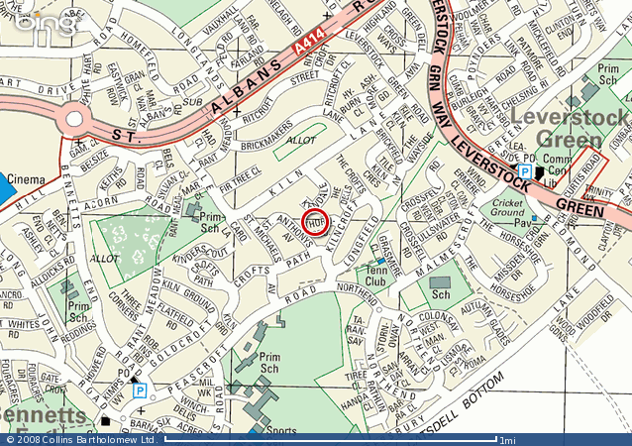
From the Magic Roundabout

- Take the A414 to the Tesco roundabout

- Go across the Tesco roundabout to the Bennetts End roundabout

- Take the 3rd exit towards Bennetts End

- Continue to the junction with Peascroft Rd

- Turn left into Peascroft Rd and continue for 400yds. The school is on your right (green double gates)

- The way into the shop is via the single gate to the right of the building as you drive in

Scout Shop

